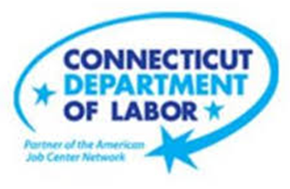

**NEW WEEKLY JOB POSTINGS FROM   
HELP WANTED ONLINE  
Office of Research**

**Week Ending May 20th, 2023: Total New Ads Down 11% Over The Week**WETHERSFIELD, May 26th, 2023 – During the week ending May 20th, 2023, there were 6,766 new postings, down 11% or   
-805 new ads from a week ago. Most of that overall decline occurred in three industries Educational Services, Manufacturing, and Professional, Scientific, & Technical Services. The three employers with the largest decline over the week were Yale-New Haven Health System (-86 new ads), Raytheon (-55 new ads), and Wheeler Clinic (-52new ads). The largest occupational declines over the week were Registered Nurses (-81 new ads), Personal Service Managers (-55 new ads), and Fast Food & Counter Workers (-52 new ads). The graph below includes total weekly new ads for Connecticut and the United States. During the week ending May 13th, Connecticut’s total ads decline of 11% was larger than the 8% decline experienced by the United States overall. The most recent week in Connecticut is down sharply from three weeks ago during the week ending May 6th, which had 7,854 total new ads.  
  
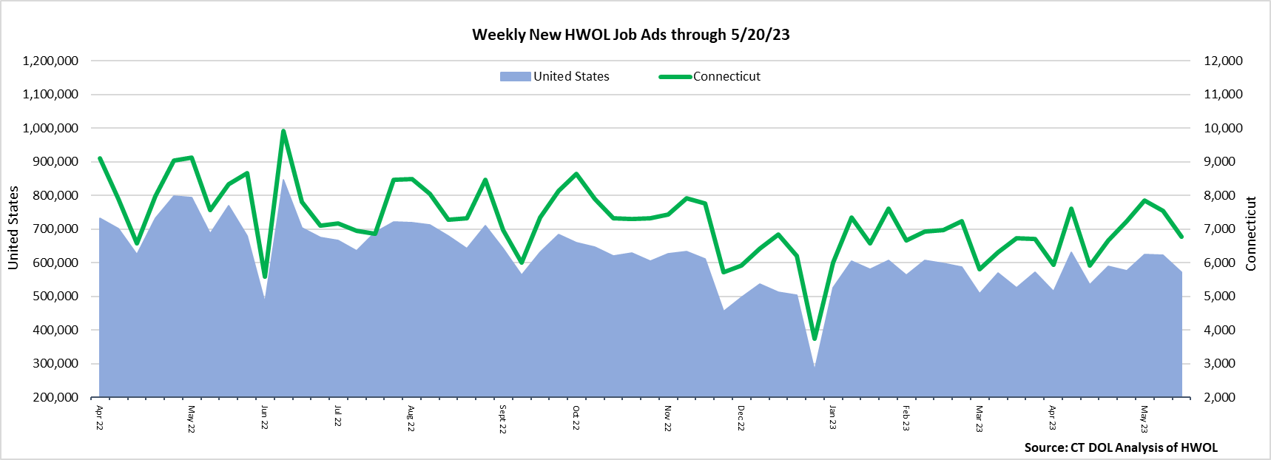  
  
**Industries** with the most new postings include Health Care & Social Assistance, Retail Trade, and Finance & Insurance.

**Occupations** with the most new postings include Registered Nurses, Retail Salespersons, and Customer Service Representatives.

**Employers** with the most new postings include Hartford Healthcare, Community Health Center, Inc., and Child Guidance Center of Southern CT.

**The three industries with the most new job postings were:**

* **Health Care & Social Assistance** (1,773 new postings, -0.4% over the week)
* **Retail Trade** (829 new postings, +19% over the week)
* **Finance & Insurance** (602 new postings, -9% over the week)

   
 During the week ending May 20th, 19 of 21 industries decreased. The largest industry decreases occurred in Educational Services (-155 new ads), Manufacturing (-148 new ads), and Pro., Sci., & Tech. Services (-78 new ads). These three industries accounted for 47% of the total decline across all industries. The largest over-the-week employer declines in these three industries were Middletown Public Schools (-29 new ads), Raytheon (-55 new ads), and Lumen Technologies (-42 new ads) respectively. 12 industries had over the week decreases between -21% and ‑43%. The only industry with a large over-the-week increase was Retail Trade (+130 new ads). Total ads were down 1,644 new ads from four weeks ago. The largest four-week industry declines occurred in Manufacturing (-428 new ads), Retail Trade (-200 new ads), and Finance & Insurance (-193 new ads).  
   
 For more information on total job ads by industry for Connecticut and its labor market areas, see the monthly report available here: <https://www1.ctdol.state.ct.us/lmi/hwol.asp>

**New Job Postings by Occupation** 

**The occupations with the most new postings were:**

* Registered Nurses (313 new postings, -21% over the week)
* Retail Salespersons (270 new postings, +12% over the week)
* Customer Service Representatives (247 new postings, +42% over the week)

**Employers with the Most New Job Postings** Employers with the most new job postings during the week ending May 20th were mostly within Health Care & Social Assistance, Retail Trade, and Educational Services. The employers with the most new ads in these three respective industries were Hartford Healthcare (191 new ads), Walgreens Boots Alliance (145 new ads), and the University of New Haven (71 new ads). Overall, the 25 employers with the most ads account for a combined 25 percent of total new ads. Among the 25 employers shown above, 19 increased, one was unchanged, and 5 decreased.   
  
**What is HWOL?**The **Conference Board Help Wanted Online**® Data Series (HWOL) measures the number of new, first-time Online job postings and jobs reposted from the previous month for over 16,000 Internet job boards, corporate boards, and smaller job sites that serve niche markets and smaller geographic areas. To view more HWOL data, go to: <https://www1.ctdol.state.ct.us/lmi/hwol.asp>